Experiment – 3

Create a simple cloud software application for Property Buying & Rental process (In Chennai city) using any Cloud Service Provider to demonstrate SaaS.
AIM:
To develop a Property Buying and Rental Management System for Chennai city as a SaaS application using Zoho Creator.
PROCEDURE:
1.Sign in to Zoho Creator using a valid account and initiate the development process by creating a new cloud-based application, establishing the foundation for the real estate management system.
2.Design a Property Details form to systematically record essential information such as property location, type of property, price, and current availability status, ensuring accurate data management and easy tracking of listings.
3.Create an Owner Details form to capture and maintain comprehensive information about property owners, including their contact details and ownership records.
4.Develop a Buyer or Tenant Details form and integrate it with the Property Details form using lookup fields, enabling a relational connection between properties and interested buyers or tenants for efficient transaction management.
5.Configure automated workflows within the application to update the property’s availability status automatically when it is sold or rented, reducing manual effort and minimizing errors.
6.Deploy and publish the completed application as a cloud-based service, allowing authorized users to securely access and manage the system online.
7.After completing these steps, the cloud-based real estate management software is successfully developed and made available for use.
IMPLEMENTATION:

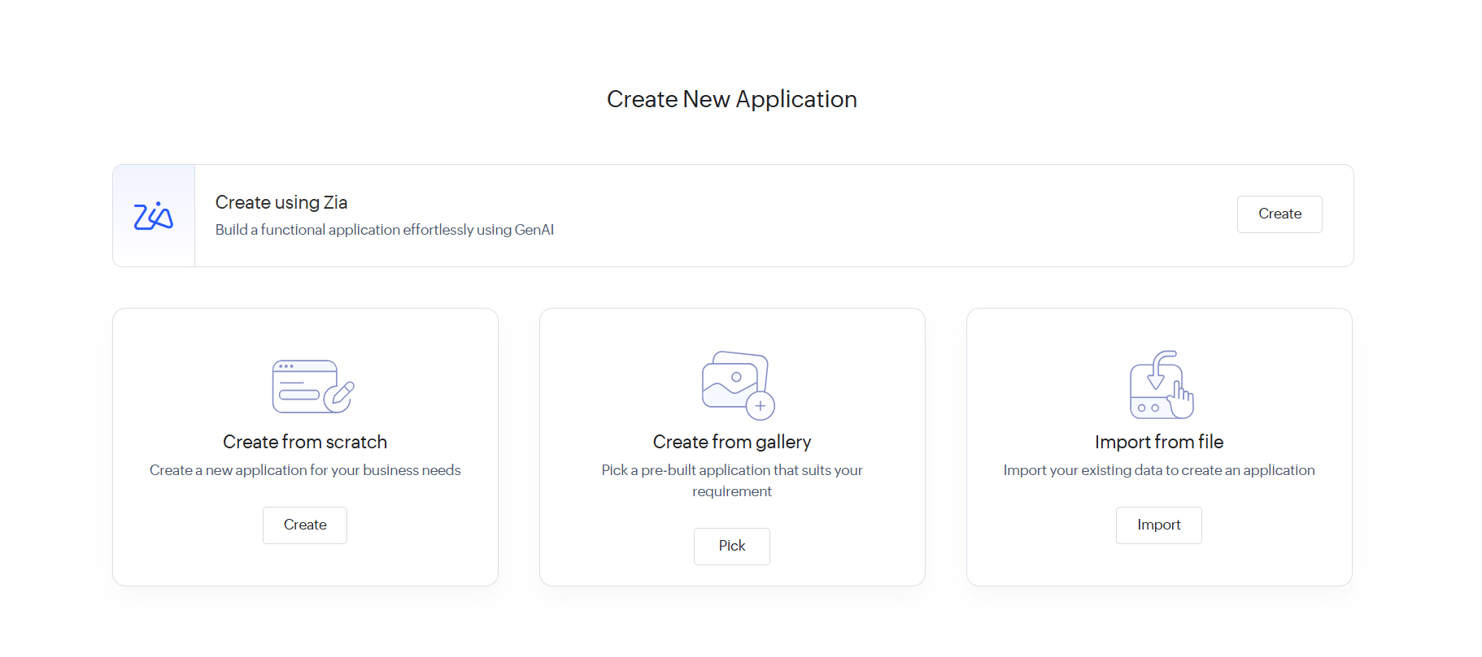
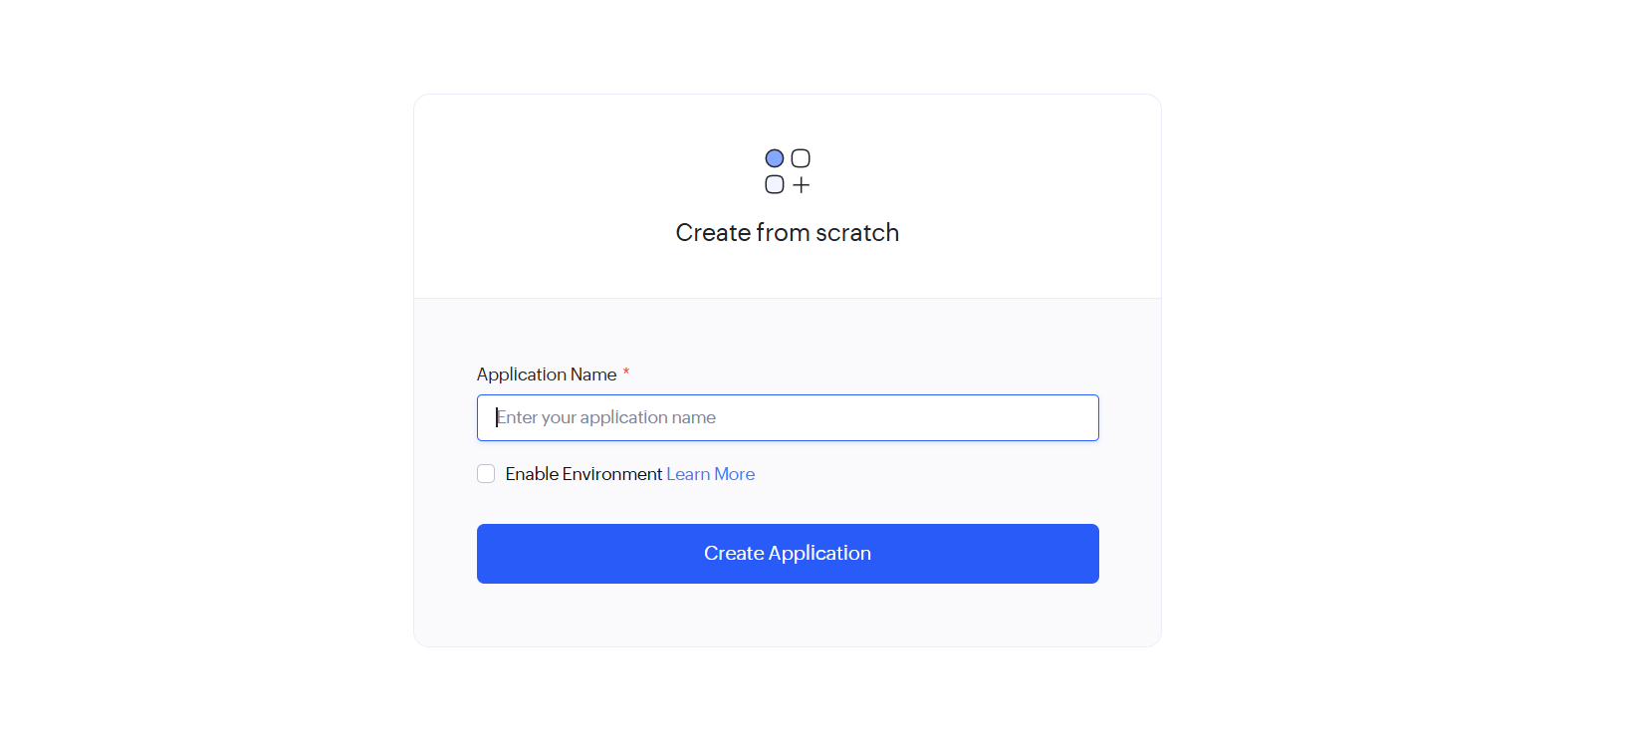

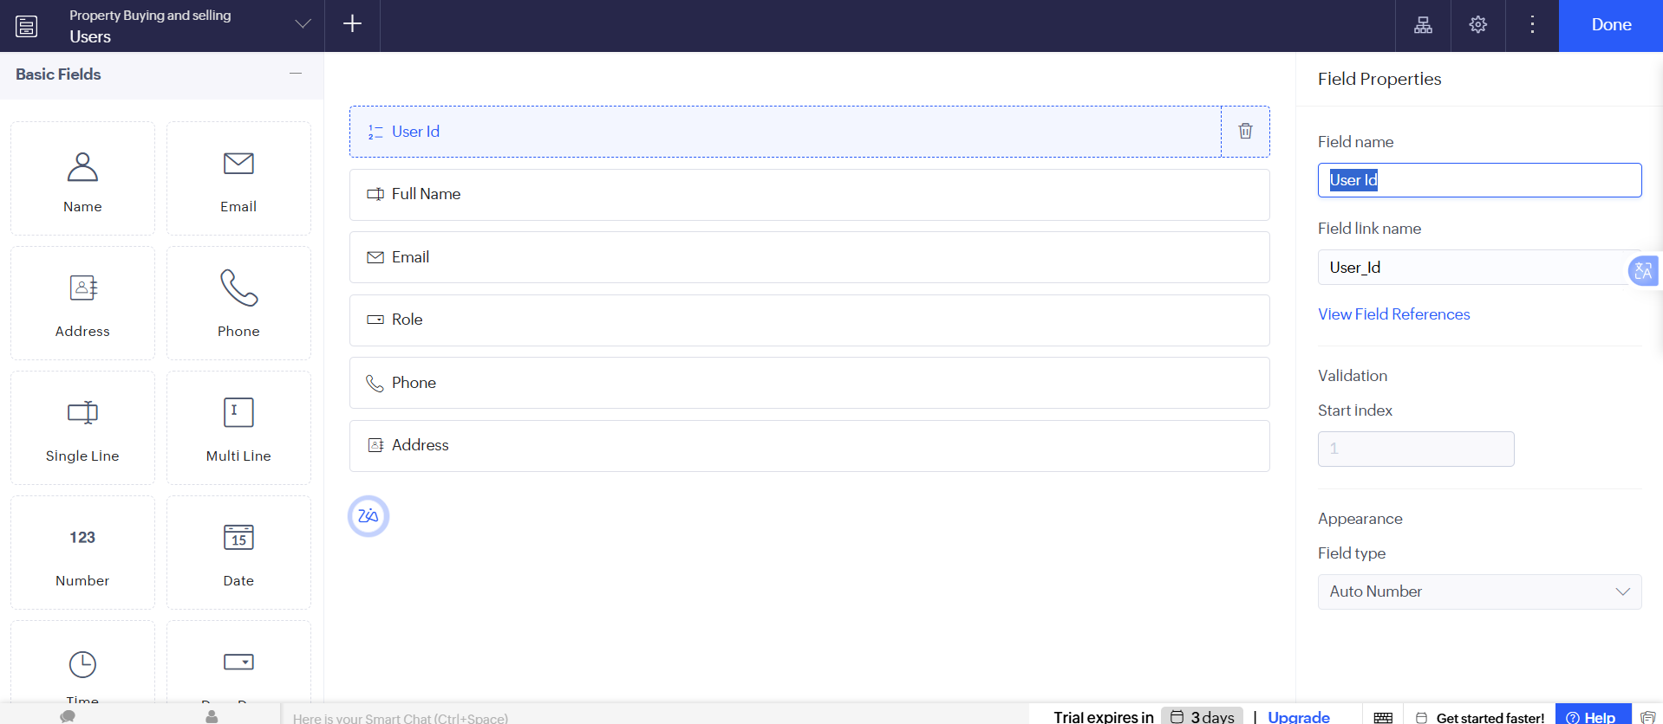

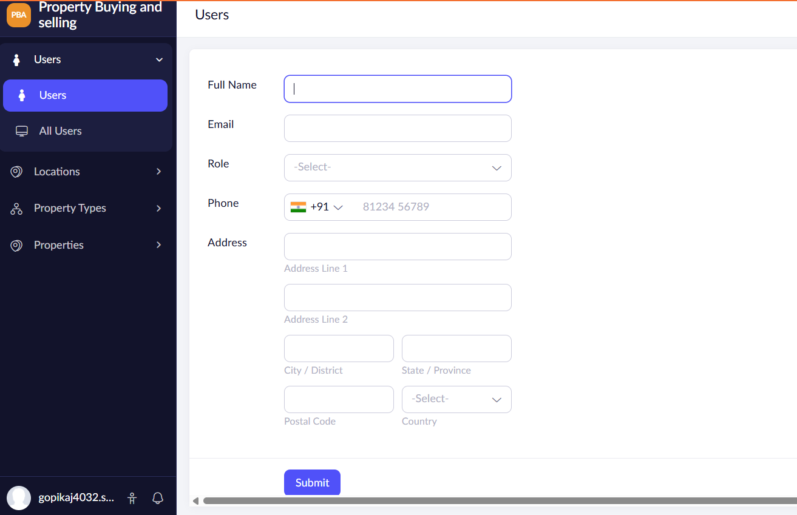
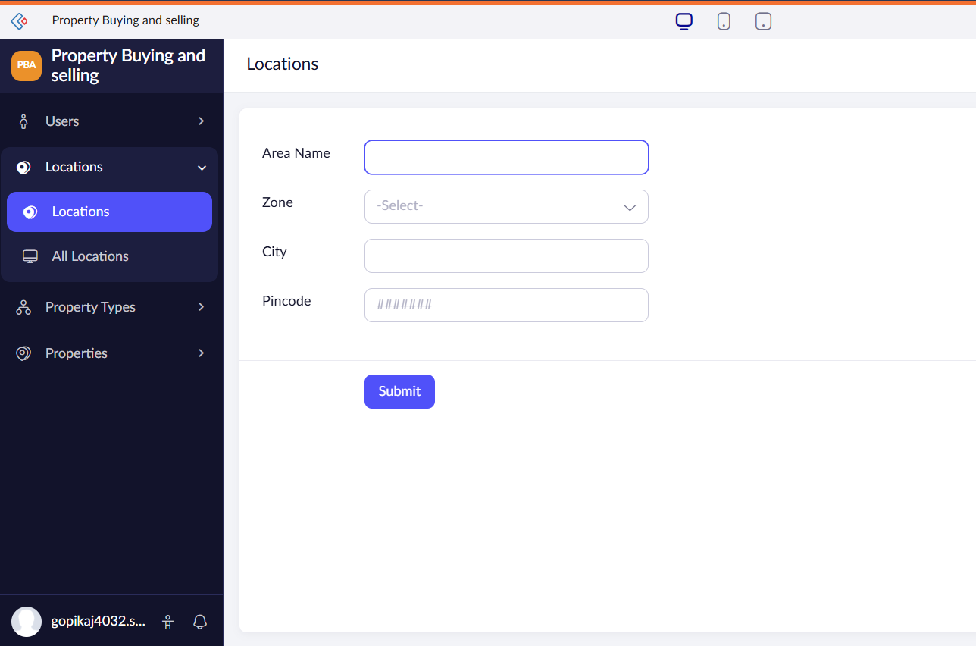
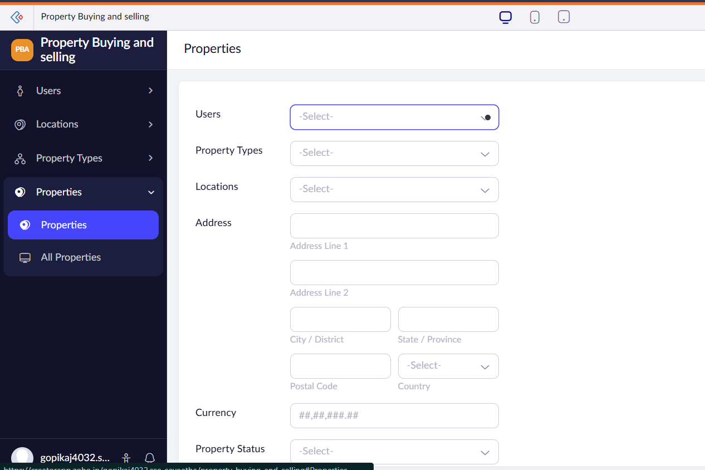

RESULT:
A cloud-based Property Buying and Rental System for Chennai city is successfully developed and delivered as a SaaS application, enabling online property management and customer handling.

